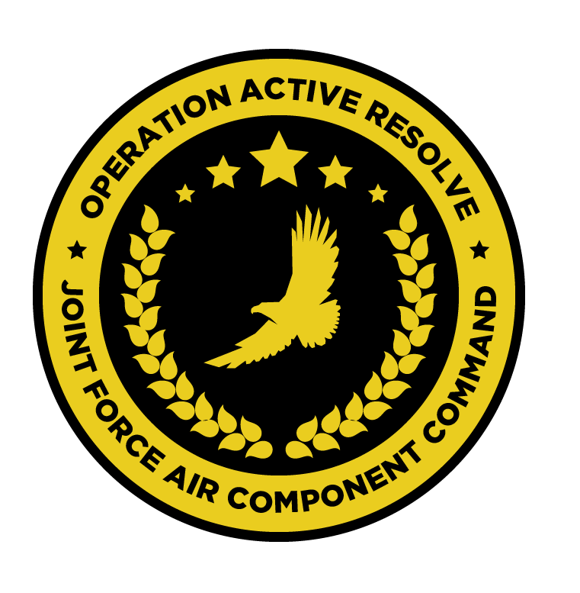

JFACC AIR OPERATIONS DIRECTIVE

OPERATION ACTIVE RESOLVE

D+X

# 1. SITUATION

## a. JFC guidance (verbatim).

(1) JFC’s intent statement.

(2) Execution guidance (if issued).

(3) Supported and supporting command relationships.

## b. Enemy situation.

## c. Friendly situation.

# 2. MISSION The JFACC’s mission statement (verbatim).

Taken from latest version of Joint Air Operations Plan (JAOP).

# 3. EXECUTION–AIR OPERATIONS

a. JFACC’s intent.

(1) Purpose.

(2) End state.

b. Execution: What to do, when. – Any detailed instructions if needed.

c. Focus of effort by objective.

d. Allocation of sorties (in percent) - CAS, AR, AI,DCA, OCA (SEAD is part of OCA)

e. Acceptable level of risk. (including for AWACS and tankers: forward or rear)

f. Collateral damage and civilian casualty guidance

g. TST guidance.

h. Intelligence, Surveillance, Reconnaissance (ISR) – If any effort should be done to support VIS with ISR to answer information gaps from VIS.

i. Other issues

j. Direction and Guidance – If there is other D&G that JFACC want to convey, it will be placed here.

Weapon status, Ref SPINS can also be ordered or specified here. For the entire area, certain regions, or certain missions. For example, within Syria airspace a weapon free can be used, while over the ocean a weapon hold or tight can be used.

If JFACC do not have anything, then a N/A will be used (N/A: Not Applicable)

# 4. ADMINISTRATION AND LOGISTICS

Logistics considerations affecting operations during the AOD period.

# 5. COMMAND AND CONTROL

C2 considerations affecting operations during the AOD period. If there are no unique considerations, refer the reader to the JAOP commander relationship annex.